Competitive Research Grants to Develop or Validate Innovative Methods and Metrics for Agriculture and Nutrition Actions

Led by London School of Hygiene & Tropical Medicine (LSHTM)

Full Proposal Frequently asked questions

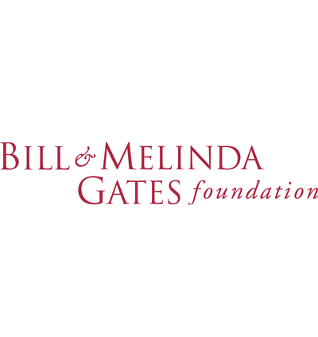

Funded by:

- What is the impact of COVID-19 on the IMMANA Grants funding?
The Foreign, Commonwealth and Development Office (FCDO) have advised that there are likely to be budget cuts which will affect their funded projects in the next financial year (2021/22) due to COVID-19. In view of this, we anticipate that the number of grants awarded in Round 4 will be reduced, however we don’t have information yet on the final number of grants which will be awarded.

- What does the “location of research” question refer to, is this question asking about where the data was collected or for secondary analysis, or is it asking where the analysis will be done?
The location of the research refers to where the data will be or has been collected from, whether primary or secondary.

- In Section 2 of the IMMANA Full Proposal Template, 8 pages are recommended for the research proposal and then there are a lot of boxes for each specific question. We assume we should be inserting texts directly into the boxes, rather than typing 8 pages in a blank word document, correct? Also, can we delete instructions, the 1 of 2 questions in 2.1 that isn’t applicable, etc?
Yes, the text should be inserted into the boxes, and not in separate pages. You may delete the question which is not applicable under 2.1, however please do not delete the instructions for any other sections.

- Regarding the request for a “Letter of support from each institution named in the application form”, is this referring only to sub-grantees or to any organization mentioned? Is this about receiving support letters from those receiving money or hosting activities or even collaborators e.g. members of an Advisory Committee?
Letters of support need to be included for every institution with which you will have a formal collaboration or partnership. So this will include sub-grantees but not necessarily include advisory committee members if they are not part of an institution with which you have a formal collaboration.

- Section 3.1 eligibility in the guidelines notes that “any changes to approved concept note in terms of scope, objectives, purpose, relevance, and partnership are not allowed”, yet the feedback we received suggested some changes.
The only concept note changes which will be allowed are those which have been identified within your feedback.

- Does the £250,000 exclude indirect costs?
No. The £250,000 grant limit is the total amount that can be allocated to any one grant. This limit will need to include any indirect costs.

- Do you support indirect or overhead costs?
Budget guidelines can be found in the Call for Applications. The budget must be in pound sterling (£). Indirect or overhead costs are permitted up to 15% of the total budget.

- What are the costing guidelines for UK universities? According to the guidance, the costs include estates and overheads. Is the costing at full economic cost (FEC) or 80%?
The IMMANA grants are available to applicants internationally and are not restricted to UK applicants, which is why there is no specific guidance on the costing procedures followed by UK universities. Indirect costs are permitted but the bulk of the costs of the budget should be for direct costs such as salaries and transport. All applications will be reviewed for value for money and this should be a consideration when putting together budgets.

For the purposes of IMMANA, ‘Direct costs’ include salaries of directly hired project personnel, travel for project personnel, supplies directly related to the project, sub-contracts, publication costs etc. For IMMANA, ‘indirect costs’ include overhead expenses which are incurred as a result of the project, for example use of existing shared equipment for the purpose of the project, grant management directly related to the project and project related travel insurance. Overall, we expect these costs to be kept to a minimum and the indirect costs are expected to facilitate effective implementation of the proposed project.

Including indirect costs that are not easily identifiable within the budget and are not directly related to the proposed project is strongly discouraged (examples include administrative, legal, audit, human resources, facility and equipment maintenance, library and IT support and grant management expenses that are related to overall general operations of the organisation). Indirect and estate costs approved may be up to 15% of the proposed budget and will be based on rigorous evaluation for value for money.

- We've noted that the cap on indirect costs at 15%. Between the partner organizations, do you expect one organization will be the lead and make a sub-award to the second organization, or will awards be administered to each organization separately?
We expect that there will be a lead organisation who will in turn make sub-awards to their collaborators. The lead organisation will treat all of its sub-award’s as direct costs, and charge overheads on their total budget. Where applicable, sub-awards should charge no more than 15% of their respective budgets.

- Does the space limit for section 7 - Budget breakdown and justification include also the Value for Money part or the latter is separate?
The space allocated to Section 7 should include the ‘Value for Money’ statement.

- Should host institutions also provide a support letter?
Yes, all institutions involved in the research project need to provide support letters.

- We are having trouble securing support letters for our submission due to the situation with covid-19, what should we do?
Support letters can be submitted at a later date, please write to immanagrants@lshtm.ac.uk to let us know.

- How do we address covid-19 in our grant application? Are there any new requirements around the pandemic?
There are no new requirements for including covid-19 within your grant application. However, you should let us know if covid-19 is likely to pose a risk to your project within the risk management section. In addition, it would be important to include it within the scientific rationale section where relevant.

- Under Section 6.2, profile of investigators, is this a separate section that should be completed on behalf of all the investigators, i.e. the top 5 publications as a group we feel best support our research plan? Or does this section need to be completed for every investigator?
The instruction refers to the CV or profile for individual investigators, and so needs to be completed as such. We are interested mainly in research publications, which show that the investigator has a track record in producing publications, and they do not need to be included if the information is not available. However, if there are other reports/grants which may be relevant to your application, please include them. Please note that the maximum is five per investigator.

