Breakout Rooms session – User Guide

Please go to: http://www.fao.org/gift-individual-food-consumption/en/
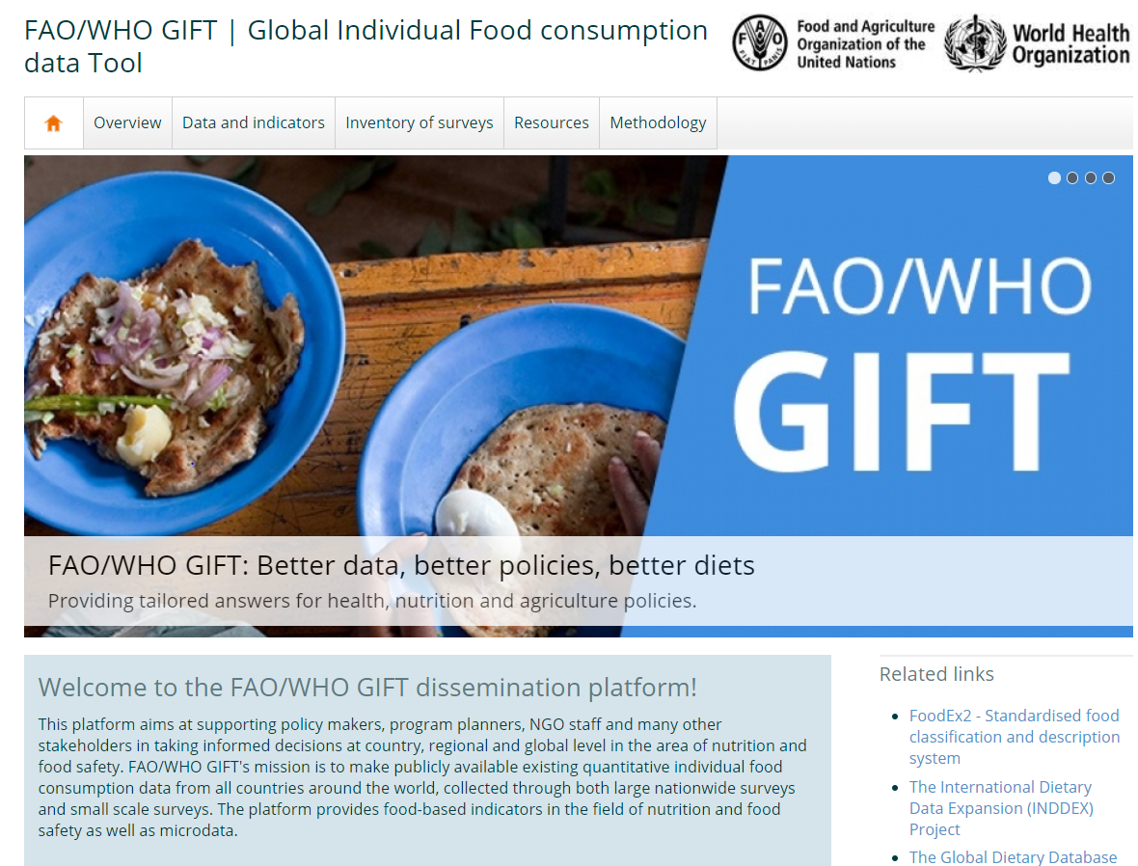

Now click on the tab “data and indicators”: http://www.fao.org/gift-individual-food-consumption/data-and-indicator/en/. For example, if you select the Argentina dataset you can click on Download to get the full dataset or Indicators.
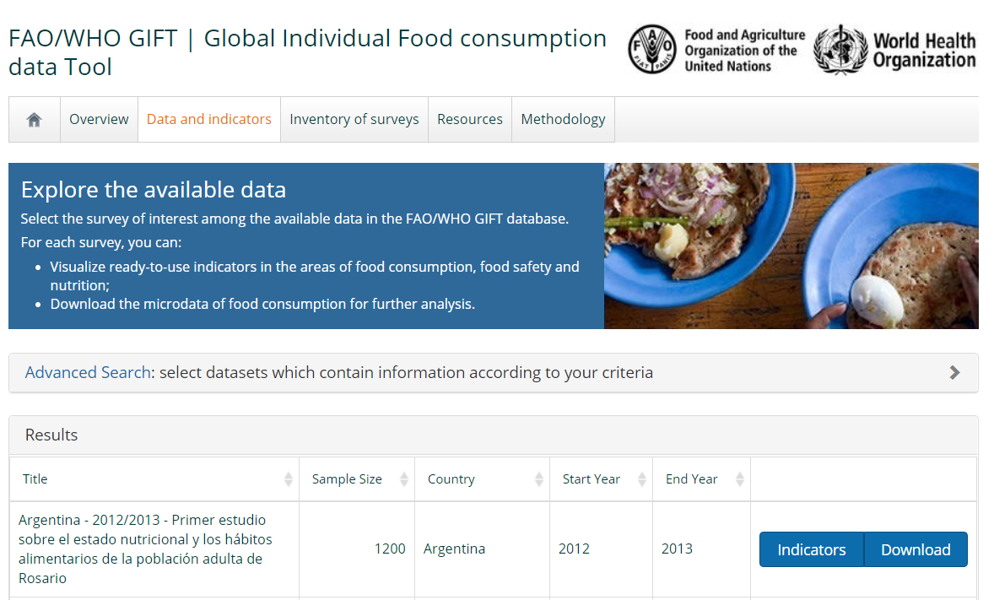
If you click on Indicators you will see the screen below. For Argentina, this dataset is from the 2012-2013 sub-national survey-covering adults aged 18-70 years. For each dataset, you can filter by sex, age, or type of area, according to the information available in the dataset.
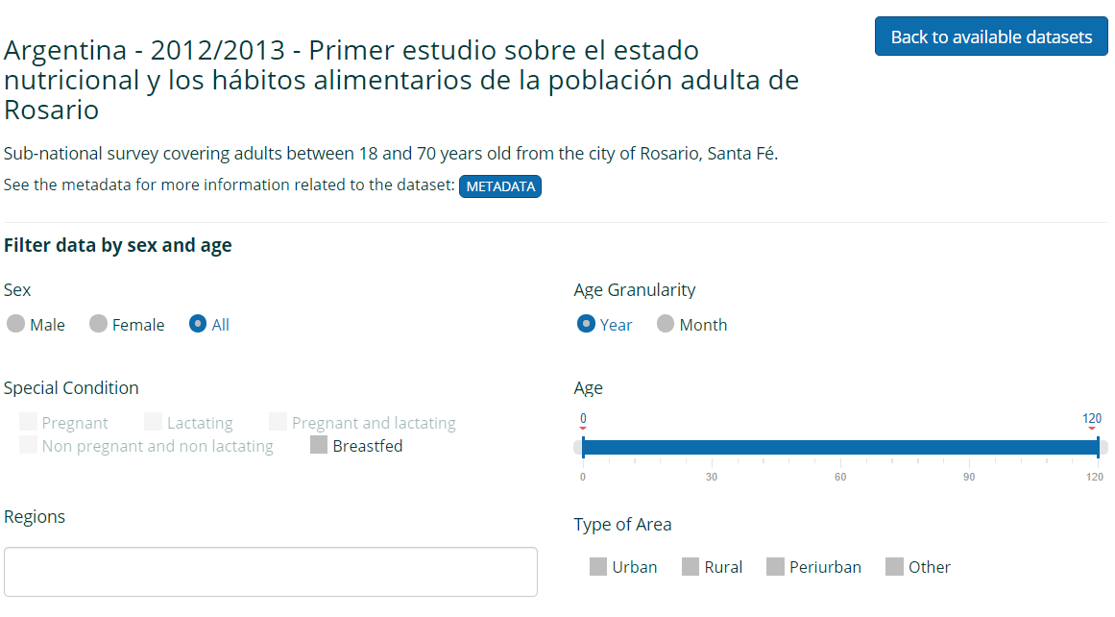

Below the filters that can be applied to the data you will see the indicators section for Food Consumption, Food Safety and Nutrition. Let’s take a look at each type of indicator!

For food consumption, you can see the average intake of grams per person for foods and beverages per day. The size of the bubble within the circle is an indication of the number of grams. If you click on the bubble you will get more information on the type of food – e.g. Vegetables , mostly consumed.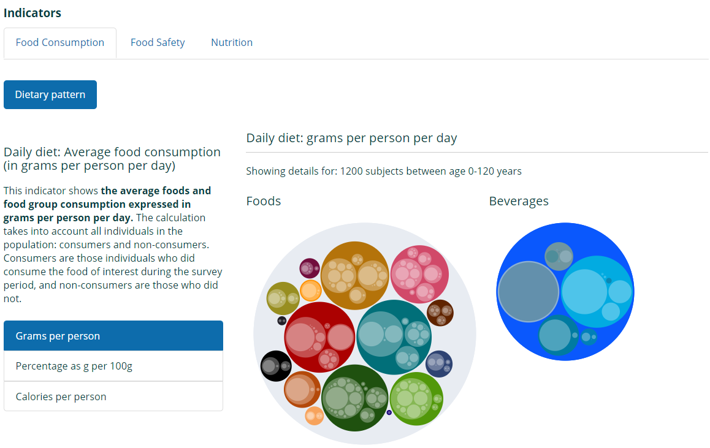
For food consumption, you also have the average percentage contribution of different foods to the total consumption in grams. This helps to show what good groups contribute to the daily diet. In this example, we see that the grams contributed from the group of sweets and sugars contribute the same as fruits.
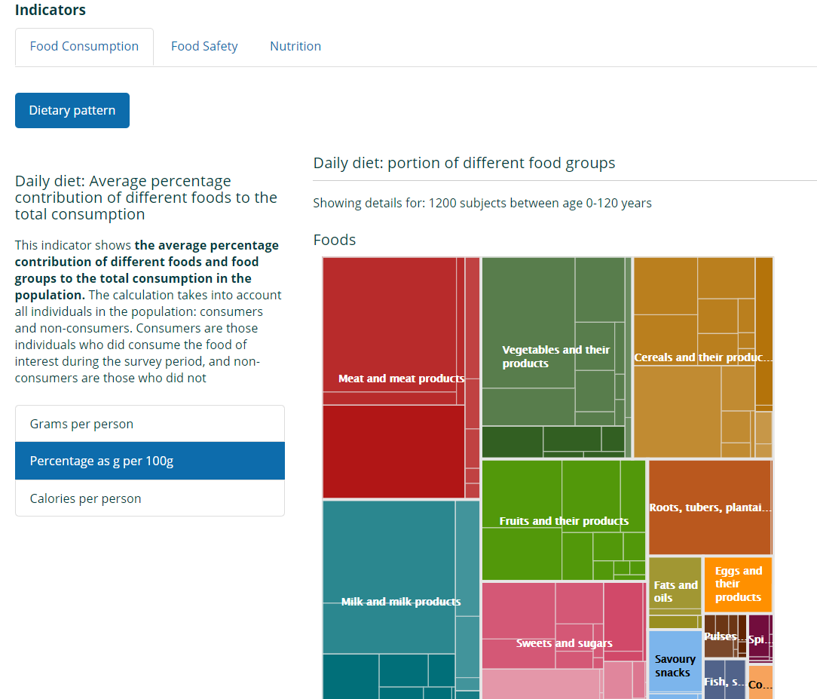

For food consumption, you have also the average daily calories consumed per person.
Here we see that for the total population, men and women included, the average daily calorie intake is 1847 calories. Note that this is the average for the whole sample. If we had selected only the men or women using the filters at the start we would see the results by sex.
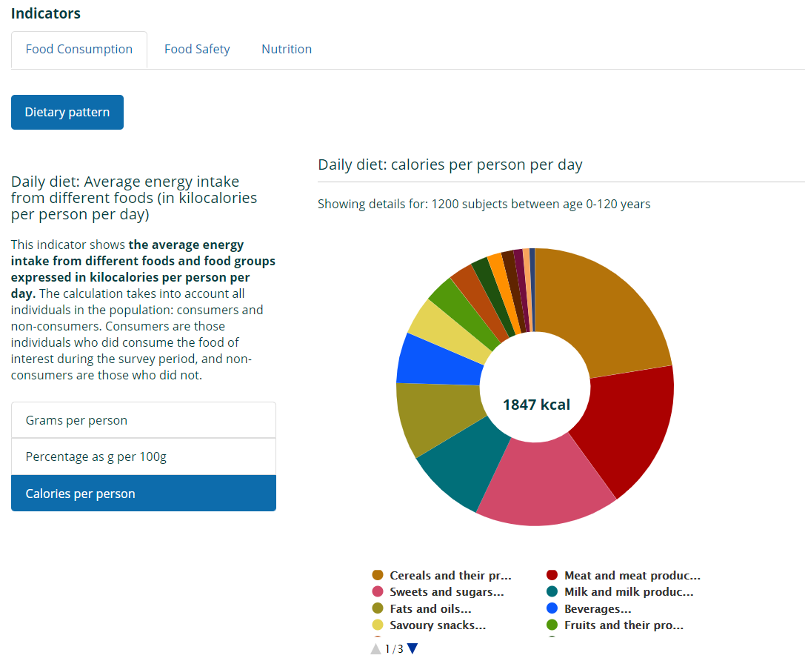
Now let us look at the Nutrition tab! Here you can click on the tab ‘sources of micronutrient in the diet’. You can see the average daily intake and the foods that are contributing to the micronutrient intake you selected in the diet.
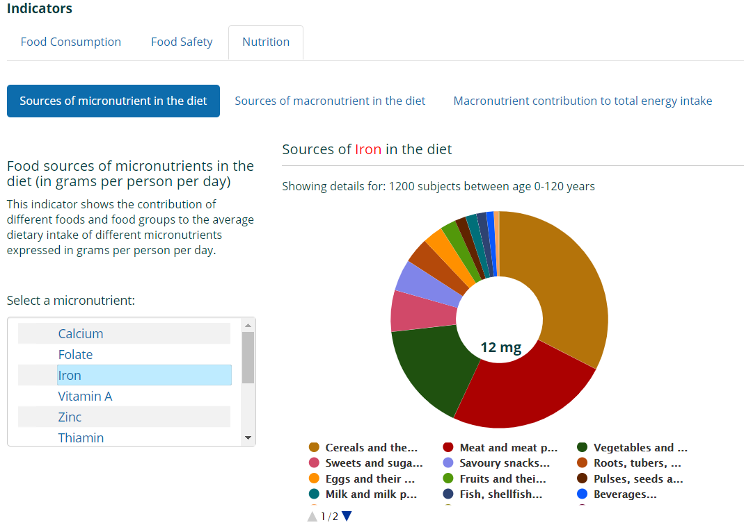
Likewise, you can click on the sources of macronutrients in the diet, and again select a nutrient – carbohydrate for example- to see the sources of carbohydrate in the diet.
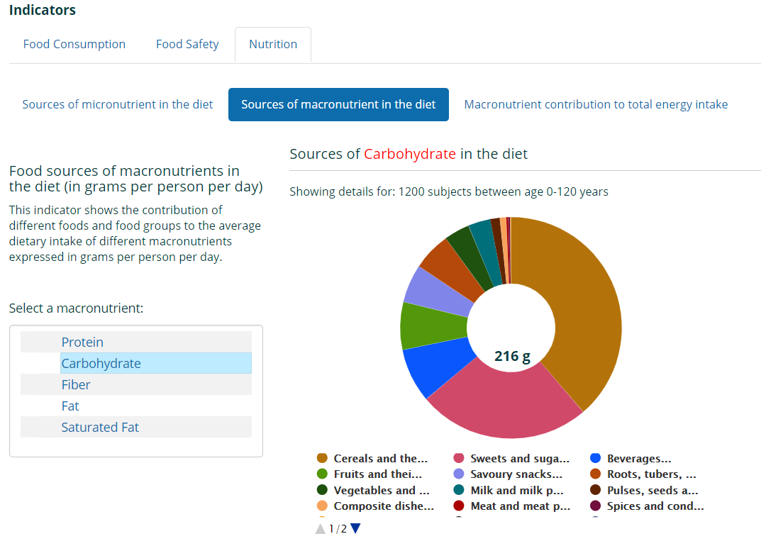
You can click on the tab ‘macronutrient contribution to total energy intake’ to see the macronutrient contributions. Here we can also compare the intakes to recommendations. 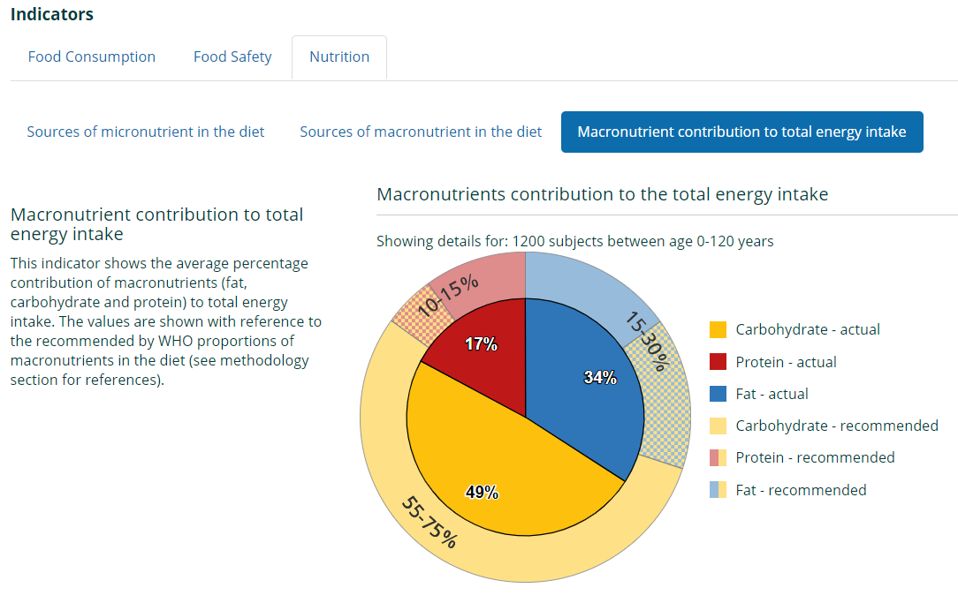

Finally, if you click the tab for food safety, you are able to see the extremes in the intakes – so we can look at the very high consumers of certain food groups, which is informative for food safety to understand potential risks.
