Overview of SEEMS-Nutrition Generic Tools

The SEEMS-Nutrition Common Approach delineates six key steps to the conduct of costing studies integrated with effectiveness studies or impact evaluations:

- Design study
- Delineate project activities and align to SEEMS-Nutrition codes
- Collect qualitative data
- Obtain and analyze financial data
- Estimate economic cost
- Combine financial and economic cost

SEEMS-Nutrition has developed a set of generic tools that are aligned to each of these steps, as described in the figure below. These can be adapted to support costing of diverse multi-sector nutrition programs.

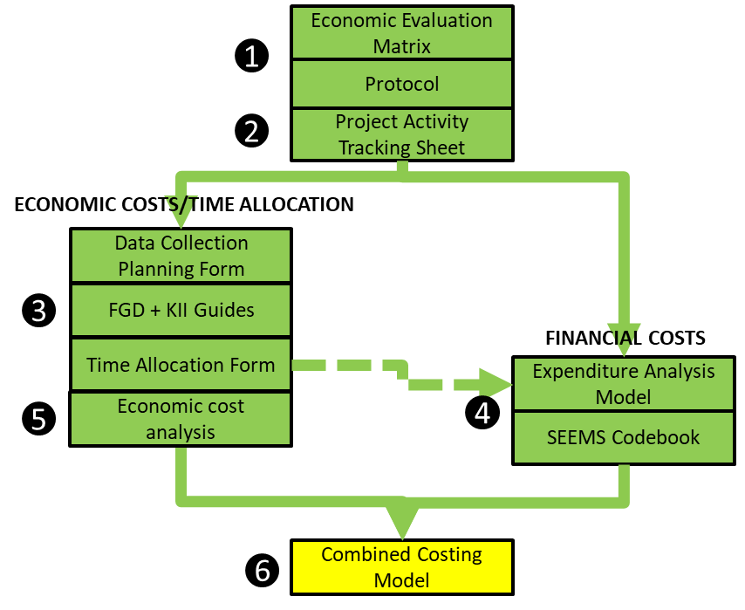

Economic Evaluation Matrix

The economic evaluation matrix supports investigators to define the scope and key parameters of their study. Investigators must define their study objectives, which costs they will include and exclude, how they will collect the costing data, who they will sample, and what time frame they will consider. These parameters will always depend on the study research question and objectives.

Protocol

A generic costing study protocol allows investigators to describe their study in more detail, in alignment with the Global Health Cost Consortium standards for costing studies. The generic protocol includes recommendations for the application of common costing methods, as well as considerations around data management and human subject protection.

Project Activity Tracking Sheet

An essential step of a costing study is to clearly describe all the components and activities of the program in question, including an indication of who carries out those activities and when they happen over the life course of the project. Investigators can use this project activity tracking sheet to detail all of the program’s sub-activities that are carried out to each the program objectives. Each activity is assigned a standardized code, promoting the comparability of the costing study and the assessment of key cost drivers of the overall program.

For each activity, investigators identify who is incurring costs, what types of costs those are, and what data sources will be used to estimate those costs.

The activity-tracking sheet has several worksheets to allow for shared program activities and separate worksheets to capture sector specific program components.

Data Collection Planning Form

The goal of the qualitative data collection is to sample enough project staff, volunteers, beneficiaries, and other stakeholders to derive valid, representative, and reproducible estimates of the time they spend in project activities (or travelling to those activities), in addition to their out of pocket costs and opportunity costs. If your study objective calls for stratification of estimates by some factor, for example rural vs. urban implementation contexts, then it will be necessary to sample accordingly.

Investigators can use the data collection planning form to outline their sampling frame, the numbers of different types of staff, partners, and beneficiaries they hope to observe or interview at each level of the sampling frame, and the time that will be required to do so. The planning form assists in calculating field travel required to complete this data collection.

Generic Key Informant/Focus Group Discussion Guides and Time Allocation Form

Interviews, focus group discussions, and passive/active observation are used to understand participation in project activities, the frequency and duration of those activities, out of pocket expenses (for example, travel costs), and opportunity costs (for example, missed wages at work, paying for childcare).

SEEMS-Nutrition has developed a series of generic interview and focus discussion guides available for adaptation to diverse contexts. These are designed for project beneficiaries, program staff, government partners, and front-line workers.

SEEMS-Nutrition has also developed a simple form to support investigators to understand how staff spend their time across project activities, in order to allocate their salary expenses to different activities. Staff are asked about their total time allocation to different project activities for each project time period.

Financial Expenditure Analysis Model and SEEMS-Nutrition Codebook

SEEMS-Nutrition has developed a simple, Excel-based expenditure analysis template. Investigators input raw expenditure data, convert it to a standard USD amount, and then code it by input type and activity. Expenditure can also be coded by platform, sector, trial arm, or other factors. Large up-front costs can be annualized. Where available, expenditures can be linked to standardized account and monitoring codes to support contextualization of expenses. The expenditure analysis template produces simple summaries of project expenses by input type, activity type, program year, etc.

Economic Cost Analysis Model

The economic cost analysis model supports investigators to summarize qualitative data and calculate average economic costs for different types of project beneficiaries, partners, and front-line workers. These are costs not captured in program financial data. The model also supports investigators to extrapolate from individual economic costs per person to overall economic costs at the level of the program.

Combined Costing Model

Finally, SEEMS-Nutrition has developed a simple Excel template to support combination of economic and financial costs, stratified by input type, activity type, and program stage.

Access tools via this link.

Tools citation and feedback

If you opt to use any of these tools, we request that you please cite the SEEMS-Nutrition tools or reference the methodology. Each tool has a recommended citation. More importantly please provide us with feedback and suggestions for improving their use.

Questions or need technical support?
Please contact Stephanie Edlund-Cho (secho@uw.edu) and she will direct your query for a prompt reply.

References of interest
- Levin, C., Masters, W., Gelli, A., Harris-Fry, H., Kadiyala, S., Kalamatianou, S., ... & Vosti, S. (2019). Economic evaluation of multisectoral actions for health and nutrition. Agriculture, Nutrition and Health Academy Working Group of Economic Evaluations.

Application of the SEEMS-Nutrition tools
- Margolies, A., Gelli, A., Daryanani, R., Twalibu, A., & Levin, C. (2021). When Communities Pull Their Weight: The Economic Costs of an Integrated Agriculture and Nutrition Home-Grown Preschool Meal Intervention in Malawi. Food and Nutrition Bulletin, 42(1), 3-22.
- Gelli,A., Kemp CG., Margolies, A., Twalibu, A., Katundu, M., & Levin, C. (2022). Economic evaluation of an early childhood development center–based agriculture and nutrition intervention in Malawi. Food Sec. 14, 67–80 (2022). https://doi.org/10.1007/s12571-021-01203-6

